
If you are a DStv or Top TV subscriber the frustration of signal loss, especially during heavy rain may not be new to you.

Thanks to the innovative design of the LNB (Dish receiver) PROTECTOR this will be a problem of the past!

The easy to install (one-click) protector is made out of engineering plastic which is also UV resistant.
The product will enhance your dish TV picture quality and prolong the life of your LNB. Center for Polymer Technology Quality Assurance.
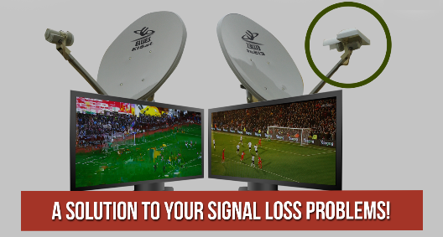

BENEFITS of the LNB Protector:
1. Patented product: National & International.
2. Protects LNB against rain and sun damage.
3. Ensures good signal during bad weather
4. Light weight.
5. Made from a durable plastic (UV resistant).
6. Saves R800 in replacement cost of LNB.
7. Free delivery within South Africa.
8. Affordable!
9. Easy to fit.


The LNB Protector has a retail value of between R115 and R120 depending on your target market and area.
PRICING:
Our pricing works as follows:
50 units @ R95 per unit
100 units @ R90 per unit
500 units @ R85 per unit
Minimum order: 50 Units
ORDERING:
Please send us your:
- Name or Company Name
- Delivery Address
- Telephone number
- Amount of units
Once we have received your proof of payment we will courier your order and send you the tracking number. Please send proof of payment to: admin@marxindustries.net

Banking Details:
Bank: FNB
Account name: Marx Industries
Account number: 6240 7675 076
Branch code: 200 311
Reference: YOUR NAME
DELIVERY:
Orders will be delivered by JKJ or TimeFreight couriers to any physical address within South Africa, excluding Soweto.
If there is any delay in delivery past 3 business days you can contact me with your tracking number directly to find the holdup.
FREE NATIONAL DELIVERY APPLIES TO ALL ORDERS.
Don't miss out! Contact us today to place your order:
Sales@marxindustries.net

Contact person: Andrew Marx
Tell: 072 751 7752
Email: Sales@marxindustries.net
Website: www.marxindustries.net

